**Topic: Matrix and Equations Applications**

Time: 45 mins Marks: /45 marks

**Calculator Assumed**



**Question One: [3, 2: 5 marks]**

The following is a network showing who has who‘s mobile numbers.

a) Construct a matrix representing this information using zeros to show where someone does not have someone else’s mobile number, ones to show where someone does has someone’s mobile number and zeros on the leading diagonal so that the situation of having one’s own mobile number is not counted.

b) Create a matrix to show how many ways each pair can communicate with each other via a third person.

**Question Two: [3, 6: 9 marks]**

Little Miss Muffet got off her tuffet and decided to create a business selling curds and whey. If she prices the curds and whey at $2.00 a bowl, she calculates that she would sell 200 bowls of curds and whey. With each $0.50 increase in price her sales will drop by 20.

a) Complete the following table to determine the sale price which maximizes Little Miss Muffet’s revenue and state this price.

|  |  |  |  |
| --- | --- | --- | --- |
| Number of $0.50 increases | Price | Number sold | Total revenue |
| 0 |  |  |  |
| 1 |  |  |  |
| 2 |  |  |  |
| 3 |  |  |  |
| 4 |  |  |  |
| 5 |  |  |  |

b) With *x* being the number of $0.50 increases in price:

i) Write an expression representing the relationship in the **price** column.

ii) Write an expression representing the relationship in the **number sold** column.

iii) Write an expression representing the relationship in the **revenue** column.

**Question Three: [1, 2, 2: 5 marks]**

Swimming’s Cool is a company which produces swimming pools. They have three different models of pool which they sell and each one requires a different amount of each of the following materials as shown in matrix **A** below.

Fiberglass Concrete Tiles Gravel

(Sheets) (kg) (number) (bags)

Model A

Model B

Model C

**A** =

a) Swimming’s Cool receives the following orders: 4 of Model A, 2 of Model B and 1 of Model C. Create matrix **B** to represent this information.

b) Use matrix methods to calculate the total amount of each material needed to fill the order.

c) The costs for each of the materials are as follows:

Fiberglass Concrete Tiles Gravel

($300/Sheet) ($50/kg) ($5 each) ($70/bag)

Calculate, **using matrix methods and showing full working**, the total cost of the order.

**Question Four: [2, 2, 4, 4: 12 marks]**

The body mass index (BMI), or Quetelet index, is a measure of relative size based on the mass and height of an individual. The BMI for a person is defined as their body mass (in kg) divided by the square of their height (in metres).

a) Write the formula for BMI based on mass in kg and height in metres.

b) Jenny is 165 cm tall and weighs 90 kg. Calculate her BMI.

c) A healthy BMI range for adults is 18.5 to 24.9 kg/m2. Jenny wants to lose weight in order to have a healthier BMI. She begins eating healthier and exercising more regularly. At the start of week 1 she weighs 90 kg and she is losing 1.2 kg steadily each week.

Continue the table below and state how many weeks it will take before Jenny’s BMI first enters the healthy range.

|  |  |  |
| --- | --- | --- |
| Week | Mass | BMI |
| 1 | 90 |  |
|  |  |  |
| 16 | 72 | 26.446 kg/m2 (3 d.p) |
|  |  |  |
|  |  |  |
|  |  |  |
|  |  |  |
|  |  |  |

d) Jenny was calculating the BMI of her brothers when she spilt her low fat smoothie and it smudged the ink on some of her calculations. Use the BMI formula to recover Jenny’s calculations.

|  |  |  |  |
| --- | --- | --- | --- |
|  | Height  (m) | Mass  (kg) | BMI  (kg/m2) |
| Craig | 1.85 |  | 22 |
| Tony |  | 100 | 30 |
| Ferguson | 1.90 | 80 |  |

**Question Five: [1, 4, 2: 7 marks]**

This is a simplified map of the Italian high speed train network for visitors.

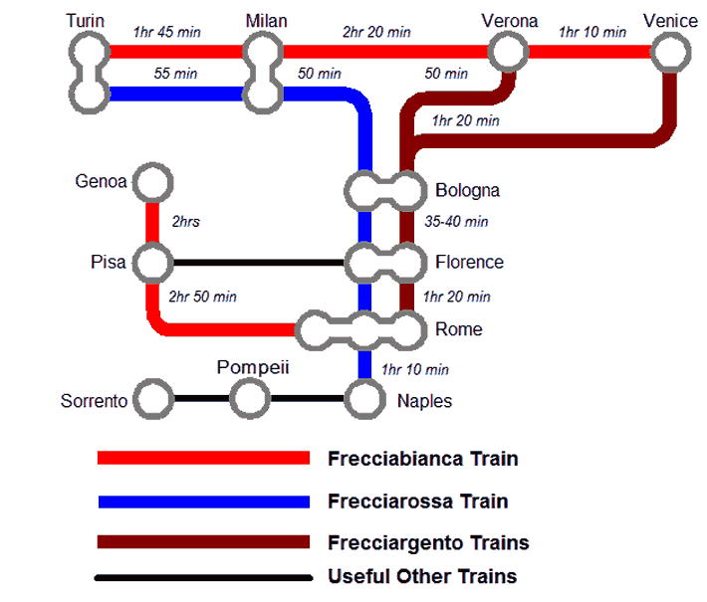

a) How many ways can a train from Rome travel to Bologna, passing through exactly one station?

b) Use the network of the Italian high speed train on the previous page to complete the following stage-one route matrix.

Turin Bologna Milan Venice

Venice Milan Bologna Turin

Venice Verona Pisa Pompeii

c) How many routes are there between stops, via another stop (Two-stage matrix)?

Turin Bologna Milan Venice

Venice Milan Bologna Turin

Venice Verona Pisa Pompeii

**Question Six: [2, 3, 2: 7 marks]**

The following table provides some information about the 187 people attending a science-fiction conference on the Gold Coast.

|  |  |  |  |
| --- | --- | --- | --- |
|  | Male | Female | Total |
| Over 30 | 60 | 55 | 115 |
| Under 30 | 45 | 27 | 72 |
| Total | 105 | 82 |  |

a) Create a 2x2 matrix, **P**, of the proportions of people in each of the categories displayed in the table above, correct to 3 d.p.

b) If the next science-fiction conference is expected to have 500 people attending, use matrix methods to produce matrix, **S**, displaying how many people we would expect in each category.

c) What does S1 1 + S1 2 + S2 1 represent?

**Matrix and Equations Applications SOLUTIONS**

Time: 45 mins Marks: /45 marks

**Calculator Assumed**



**Question One: [3, 2: 5 marks]**

The following is a network showing who has who’s mobile numbers.

|  |  |
| --- | --- |
|  | E M K G J N F |
| E  M  K  G  J  N  F | $$\left[\begin{matrix}0 & 1 & 0 & 0 & 1 & 0 & 1 \\ 1 & 0 & 1 & 0 & 0 & 0 & 0 \\ 0 & 1 & 0 & 1 & 0 & 0 & 0 \\ 0 & 0 & 1 & 0 & 1 & 0 & 0 \\ 1 & 0 & 1 & 1 & 0 & 1 & 1 \\ 0 & 0 & 1 & 0 & 0 & 0 & 0 \\ 0 & 0 & 0 & 0 & 1 & 0 & 0\end{matrix}\right]$$ |

a) Construct a matrix representing this information using zeros to show where someone does not have someone else’s mobile number, ones to show where someone does has someone’s mobile number and zeros on the leading diagonal so that the situation of having one’s own mobile number is not counted.

b) Create a matrix to show how many ways each pair can communicate with each other via a third person.

|  |  |
| --- | --- |
|  | E M K G J N F |
| E  M  K  G  J  N  F | $$\left[\begin{matrix}2 & 0 & 2 & 1 & 1 & 1 & 1 \\ 0 & 2 & 0 & 1 & 1 & 0 & 1 \\ 1 & 0 & 2 & 0 & 1 & 0 & 0 \\ 1 & 1 & 1 & 2 & 0 & 1 & 1 \\ 0 & 2 & 2 & 1 & 3 & 0 & 1 \\ 0 & 1 & 0 & 1 & 0 & 0 & 0 \\ 1 & 0 & 1 & 1 & 0 & 1 & 1\end{matrix}\right]$$ |

**Question Two: [3, 6: 9 marks]**

Little Miss Muffet got off her tuffet and decided to create a business selling curds and whey. If she prices the curds and whey at $2.00, a bowl she calculates that she would sell 200 bowls of curds and whey. With each $0.50 increase in price her sales will drop by 20.

a) Complete the following table to determine the sale price which maximizes Little Miss Muffet’s revenue and state this price.

|  |  |  |  |
| --- | --- | --- | --- |
| Number of $0.50 increases | Price | Number sold | Total revenue |
| 0 | 2.00 | 200 | $400 |
| 1 | 2.50 | 180 | $450 |
| 2 | 3.00 | 160 | $480 |
| 3 | 3.50 | 140 | $490 |
| 4 | 4.00 | 120 | $480 |
| 5 | 4.50 | 100 | $450 |



b) With *x* being the number of $0.50 increases in price:

i) Write an expression representing the relationship in the **price** column.

ii) Write an expression representing the relationship in the **number sold** column.

iii) Write an expression representing the relationship in the **revenue** column.



**Question Three: [1, 2, 2: 5 marks]**

Swimming’s Cool is a company which produces swimming pools. They have three different models of pool which they sell and each one requires a different amount of each of the following materials as shown in matrix **A** below.

Fiberglass Concrete Tiles Gravel

(Sheets) (kg) (number) (bags)

Model A

Model B

Model C

**A** =

a) Swimming’s Cool receives the following orders: 4 of Model A, 2 of Model B and 1 of Model C. Create matrix **B** to represent this information.



$B=\left[\begin{matrix}4 & 2 & 1\end{matrix}\right]$

b) Use matrix methods to calculate the total amount of each material needed to fill the order.



$BA=\left[\begin{matrix}12 & 790 & 350 & 330\end{matrix}\right]$

12 sheets of fiberglass, 790 kg of concrete, 350 tiles and 330 bags of gravel

c) The costs for each of the materials are as follows:

Fiberglass Concrete Tiles Gravel

($300/Sheet) ($50/kg) ($5 each) ($70/bag)

Calculate, **using matrix methods and showing full working**, the total cost of the order.



**Question Four: [2, 2, 4, 4: 12 marks]**

The body mass index (BMI), or Quetelet index, is a measure of relative size based on the mass and height of an individual. The BMI for a person is defined as their body mass (in kg) divided by the square of their height (in metres).

a) Write the formula for BMI based on mass in kg and height in metres.

b) Jenny is 165 cm tall and weighs 90 kg. Calculate her BMI.

c) A healthy BMI range for adults is 18.5 to 24.9 kg/m2. Jenny wants to lose weight in order to have a healthier BMI. She begins eating healthier and exercising more regularly. At the start of week 1 she weighs 90 kg and she is losing 1.2 kg steadily each week.

Continue the table below and state how many weeks it will take before Jenny’s BMI first enters the healthy range.



|  |  |  |
| --- | --- | --- |
| Week | Mass | BMI |
| 1 | 90 |  |
|  |  |  |
| 16 | 72 | 26.446 kg/m2 (3 d.p) |
| 17 | 70.8 | 26.006 |
| 18 | 69.6 | 25.565 |
| 19 | 68.4 | 25.565 |
| 20 | 67.2 | 24.683 |
|  |  |  |



It takes 20 weeks before Jenny’s BMI enters the healthy range.

d) Jenny was calculating the BMI of her brothers when she spilt her low fat smoothie and it smudged the ink on some of her calculations. Use the BMI formula to recover Jenny’s calculations.

|  |  |  |  |
| --- | --- | --- | --- |
|  | Height  (m) | Mass  (kg) | BMI  (kg/m2) |
| Craig | 1.85 |  | 22 |
| Tony |  | 100 | 30 |
| Ferguson | 1.90 | 80 |  |

Craig: $22=\frac{M}{{1.85}^{2}}$

$$M=75.3 kg$$

Tony: $30=\frac{100}{H^{2}}$

$$H^{2}=3.33$$

$$H=1.83 m$$

Ferguson: BMI $=\frac{80}{{1.9}^{2}}$

$$=22.16$$

**Question Five: [1, 4, 2: 7 marks]**

This is a simplified map of the Italian high speed train network for visitors.



a) How many ways can a train from Rome travel to Bologna, passing through exactly one station?



4 ways

b) Use the network of the Italian high speed train on the previous page to complete the following stage-one route matrix.



Turin Bologna Milan Venice

Venice Milan Bologna Turin

Venice Verona Pisa Pompeii

c) How many routes are there between stops, via another stop (Two-stage matrix)?

Turin Bologna Milan Venice



Venice Milan Bologna Turin

$$\left[\begin{matrix}1 & 1 & 0 & 0 \\ 1 & 5 & 0 & 0 \\ 0 & 0 & 2 & 2 \\ 0 & 0 & 2 & 4\end{matrix}\right]$$

**Question Six: [2, 3, 2: 7 marks]**

The following table provides some information about the 187 people attending a science-fiction conference on the Gold Coast.

|  |  |  |  |
| --- | --- | --- | --- |
|  | Male | Female | Total |
| Over 30 | 60 | 55 | 115 |
| Under 30 | 45 | 27 | 72 |
| Total | 105 | 82 |  |

a) Create a 2x2 matrix, **P**, of the proportions of people in each of the categories displayed in the table above, correct to 3 d.p.



b) If the next science-fiction conference is expected to have 500 people attending, use matrix methods to produce matrix, **S**, displaying how many people we would expect in each category.





 $S=500P=\left[\begin{matrix}161 & 147 \\ 121 & 72\end{matrix}\right]$

one mark for rounding

c) What does S1 1 + S1 2 + S2 1 represent?

This is the total number of the males and the females who are over 30.